**INFLUENCING PHYSICIAN PRESCRIBING BEHAVIOR: DIRECT-TO-CONSUMER ADVERTISING AND THE DEMAND FOR ME-TOO DRUGS**

**General Introduction**

Pharmaceutical companies invest more resources in producing and selling these drugs than in developing drugs with significant medical advancement (Angell, 2004; Goozner, 2004).

This study examines the factors that may influence physician prescribing behavior in prescribing a generic, breakthrough or me-too drug to a patient.

The increased role of patients in selecting their medication is examined through the relationship between direct-to consumer (DTC) advertising and physicians’ prescribing behavior.

Classes of drugs studied in this research: statin, cardioselective beta blockers, proton pump inhibitors and selective serotonin.

This research answers the following questions:

1. What factors influence the physician’s choice to prescribe breakthrough, me-too, generic or generic me-to question

* What characteristics of an individual will increase the likelihood that he or she will be prescribed a breakthrough, me-too, generic or generic me-too drug?
* What physician characteristics will increase the likelihood of prescribing a patient with breakthrough, me-too, generic or generic me-too drug?
* What drug characteristics will increase the likelihood of prescribing a patient with breakthrough, me-too, generic or generic me-too drug?

1. What is the relationship between direct-to-consumer advertising and prescribing physician’s choice of drugs?
2. What is the effect of direct-to-consumer advertising and price of me-too drugs on the market share of generic drugs and breakthrough drugs?

This study includes patient characteristics (patient’s age, gender, ethnicity and number of medication) and physician characteristics (specialization, region of practice and primary source of income) without any predicted effect on the physician decision to prescribe a specific type of prescription drug.

This study tests the hypothesis that an increase in price will decrease the likelihood that a drug is prescribed.

This study also hypothesizes that the increase in the length of time the drug has been in the market increases the likelihood that a drug is prescribed. Theory on physician prescribing behavior suggests that physicians tend to prescribe established drugs thus creating a positive relationship between length of time in the market and likelihood of prescribing older drugs. The hypothesis that direct-to-consumer advertising increases the likelihood of a drug from being prescribed is also tested. This research also tests whether a patient’s generous insurance coverage increases the likelihood of being prescribed a more expensive drug like me-too drug than a generic drug.

**POLICY DYNAMICS IN THE PHARMACEUTICAL INDUSTRY: AN INTERBRANCH PERSPECTIVE**

A generic drug is assumed to be an identical, or bioequivalent drug to a brand name drug in dosage form, safety, strength, route of administration, quality, performance characteristics and intended use.

Me-too drugs have similar chemical structure or mechanism of action with a drug that is already in the market which usually referred to as the breakthrough drug.

The industry argued that “attempts to determine equivalence between older and most likely cheaper drugs, would discourage manufacturers from developing new and possibly better products, even though they were likely to be more expensive” (Marwick, 2004).

The federal government has invested modest amount in comparative effectiveness studies until 2009 when Congress allocated $1.1 billion for comparative effectiveness research trough the economic stimulus law of President Obama (Chokshi et al., 2010).

The price of generic drug is about 60% of the brand name drug when there are about one to 10 firms producing a particular generic drug. The price can fall to less than half of the brand-name price when there are more than 10 manufacturers (Cook, 1998).

In 2008, the U.S. pharmaceutical industry spent around $18 billion dollars on advertising and promotion (IMS Health, 2008). This includes direct-to-consumer advertising, detailing and advertising in professional journals. But if we include spending on continuing medical education (CME), travel and lucrative honoraria to medical professionals, marketing expenditure directed to medical professionals alone could reach up to $25 billion each year (Donohue et al., 2007). Pharmaceutical detailing is one of the most aggressive marketing strategies of the pharmaceutical industry. This involves regular visits from medical sales representatives which provide free meals, gifts and drug samples. The industry employed 87,892 detailers in 2001; a ratio of 1 medical sales representative for every 5 physicians (Chin, 2002). Industry spending on lunches for doctors is estimated at roughly $1 billion a year (Saul, 2006). Around 94% of physicians have accepted some form of gifts from the pharmaceutical industry (Campbell, 2007).

On August, 2005, the Pharmaceutical Research and Manufacturers of America issued voluntary guiding principles on direct-to-consumer advertisement for the industry. The PhRMA guidelines encourage pharmaceutical companies to spend appropriate time educating health professionals about new medication before advertising directly to consumers. The organization also advised member companies to submit all new DTC television ads to the FDA before they are released for broadcast.

Because of the growing call to limit the influence of pharmaceutical marketing, some members of Congress responded by proposing the Physician Payments Sunshine Act 2007 which “would require drug and medical device manufacturers with more than $100 million in annual revenue to report all gifts over the amount of $25 given to physicians, clinicians and other prescribers, which would be registered in a national and publicly accessible online database.”

The Physician Payments Sunshine Act of 2007, supported by both Democrats and Republicans, was proposed at the US Congress to regulate and make transparent the gifts that pharmaceutical companies are giving to health professionals. However, it was not put into law until 2009 when provisions of the proposed legislation were eventually adopted in the Patient Protection and Affordable Care Act (PPAC).

Substitution laws allow pharmacists to substitute generic drugs for multi-source drugs unless prohibited by the physician explicitly.

The Medicaid law allows the federal government to negotiate with pharmaceutical companies regarding the “best prices” they can offer for Medicaid beneficiaries.

The increasing cost of prescription drugs has forced both the federal government and the state governments to find ways to make prescription drug more accessible to individuals who need them but cannot afford them. There are four main policies in ensuring the accessibility of prescription drugs:

a) prescription drug coverage under Medicare

b) generic substitution laws

c) prescription drug (re)importation

d) the different cost containment strategies of state governments.

**PRESCRIPTION DRUG CHOICE: EXAMINING PHYSICIAN PRESCRIBING BEHAVIOR**

Physicians prescribing behavior is based largely on customary prescribing rather than on comparative effectiveness of prescription drugs (Caves et al., 1991).

When physicians and patients have no sufficient knowledge about the intrinsic qualities of competing products, brand names and level of advertising are cues usually use to measure the quality of a product (Agarwal & Teas, 2002; Valarie A. Zeithaml, 1988; V.A. Zeithaml, 1991).

Some experts criticize direct-to-consumer advertising to be misleading and increasing the demand for branded, more expensive drugs while others see the benefits of direct-to-consumer advertising as empowering to patients (Almasi, Stafford, Kravitz, & Mansfield, 2006; Auton, 2006).

Direct-to-consumer advertising encourages patients to visit the doctor for a particular illness, increasing the flow of patients treated by doctors for the particular illness. Direct-to-consumer advertising educate the patients about their undiagnosed medical conditions (Aikin, Swasy, & Braman, 2004; D. Bradford & Kleit, 2006; D. W. Bradford et al., 2006; Hosken & Wendling, 2009; Weissman et al., 2004). It has increased patients’ role in the selection of medication by pressuring physicians to respond to independent requests as encouraged by prescription advertisements (Conrad & Leiter, 2004:170).

A survey conducted by FDA reported that about half of the patient were prescribed with the medicine they asked about (Aikin et al., 2004). It averts underuse of medication by encouraging patients to talk to their doctors but at the same time it also promotes overuse of medication and increase use of advertised drugs when alternatives maybe more appropriate (Aikin et al., 2004; Kravitz et al., 2005; United States Government Accountability Office, 2006; Weissman et al., 2004).

Pharmaceutical advertising has a market expansion effect rather than combative effect. It expands the market of the entire therapeutic class (Rosenthal, Berndt, Donohue, Epstein, & Frank,2003)

Direct-to-consumer marketing has a greater effect on the sale of the entire therapeutic class while detailing has greater effect in expanding the market share of a brand (Narayanan, Desiraju, & Chintagunta, 2004). The inability of consumers to verify the quality of generic drugs in the market until they consume it makes it less attractive for some patients to shift to generic drugs. However, a recent study showed otherwise.

In a study by Ellison and Ellison (2007), they observed that incumbents in intermediate size markets have lower level of advertising and are more likely to reduce advertising before patent expiration to deter generic entry. While some researches did not find any significant relationship between advertising and new product entry (Henry G. Grabowski & Vernon, 1992; Vernon, 1971), other studies found that advertising is not a barrier to entry for new products including generic drugs (Caves et al., 1991; Leffler, 1981; Scott Morton, 2000; Telser, Best, Egan, & Higinbotham, 1975).

**PRICE**

The price of the drug is not part of the information provided by medical detailers. Physicians have very limited information on prices of prescription drugs and may not have any incentive to prescribe cheaper medicines (Caves et al., 1991). Other experts suggest that there may be other factors that may make physicians sensitive to prices. Physicians may be affected by the patients’ financial situation and the possibility that price-sensitive patients may switch to health care providers who prescribe lower-cost pharmaceuticals (S. F. Ellison et al., 1997; Gönül et al., 2001).

Patients are not directly sensitive to the price of prescription drugs because of insurance coverage on prescription drugs.

Price are sometimes use as a measure of quality (Olson, 1977).

**Drug Quality**

A more recent survey showed that consumers perception that generic prescription drugs were riskier than brand name products varied depending on the medical condition being treated.

In the case of antidepressants, some patients experienced significant difference between the effectiveness of branded and generic drugs in addressing their concerns. The approval for generic drugs require that “the rate and extent of absorption do not show a significant difference from listed drug or the extent of absorption does not show a significant difference and any difference in rate is intentional or not medically significant”(Sherwood, 2006). The FDA uses the plus-or-minus twenty percent test which implies that the amount of active ingredient in the blood over a period of time has to come within plus-or-minus twenty percent of that which is observed when the original branded drug is ingested (Mossinghoff, 1999).

Delayed or extended-release features of drugs increases patient compliance by making it more convenient for patients to take the medication like reducing the number of times the patient has to take the medication in a day (Fyhr & Downie, 2003; Schaffler, 2007). Similarly, delayed or controlled-release formulations are said to optimize treatments and make treatment more convenient to patients (Schaffler, 2007).

**DISCRETE CHOICE MODEL OF DEMAND**

This study uses the discrete choice model of demand in analyzing the relationship between physician prescribing behavior and variables that may influence it like price, direct-to-consumer advertising, quality of drugs, patient characteristics and physician characteristics.

Firms determine price and advertising based on market information and the unobservable variables that affect consumer choice. This brings about the issue of indigeneity as prices and advertising will be correlated with these unobserved demand factors.

**ANALYTICAL FRAMEWORK**

Physicians’ options in choosing medication for their patients can further be differentiated by identifying the **breakthrough drug**, the **generic version of the breakthrough**  drug, the **me-too drugs** and the **generic versions of the me-too drugs** in a specific class.

A non-sequential nested logit model, where the choices of drugs were classified into four nests ( breakthrough, generic, me too drugs and generic of me too drugs), was used to estimate equation . Nested logit models are used when there are similarities among alternatives. It classifies the alternatives into nests which comprises the choice set, which in this study are the types of prescription drugs. This model relaxes the assumption of independently distributed errors and the independence of irrelevant alternatives inherent in conditional and multinomial logit models by clustering similar alternative into nests (StataCorp, 2007).

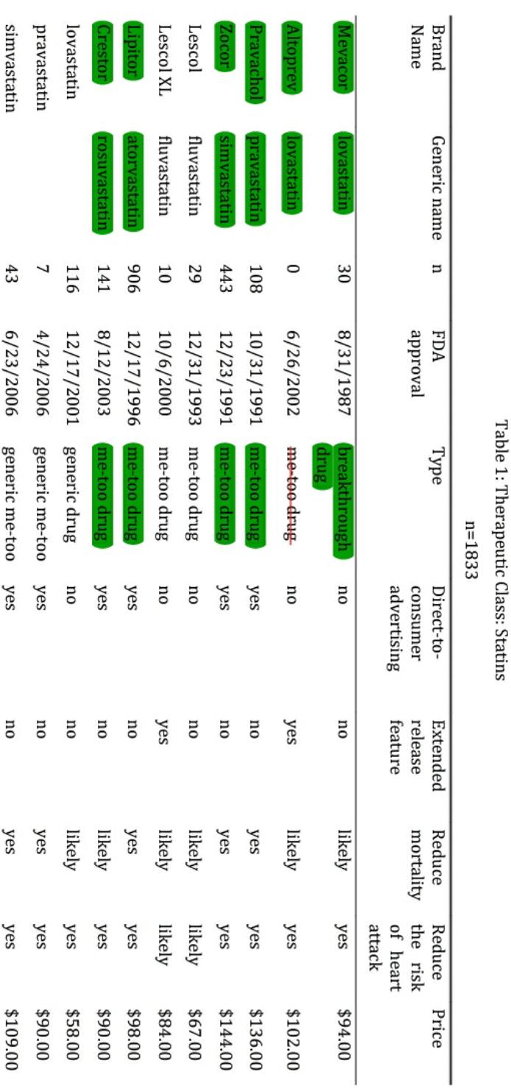 **SAMPLE: MHG-COA REDUCTASE INHIBITORS (STATIN DRUGS)**

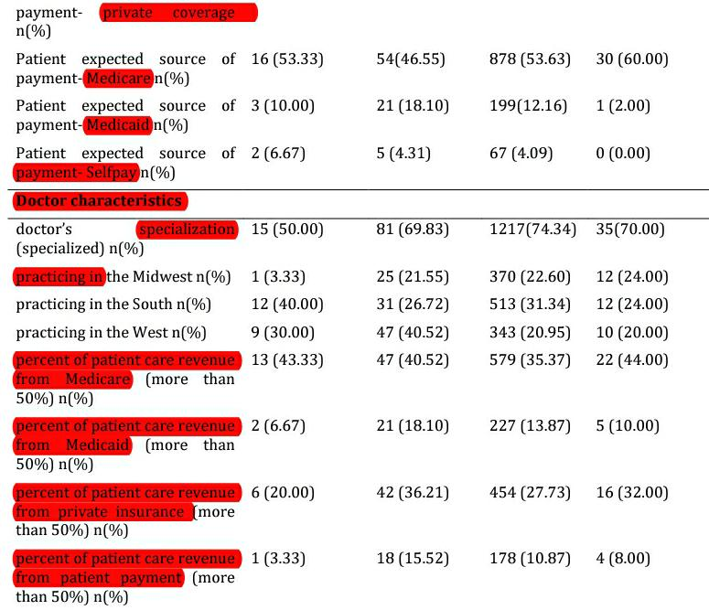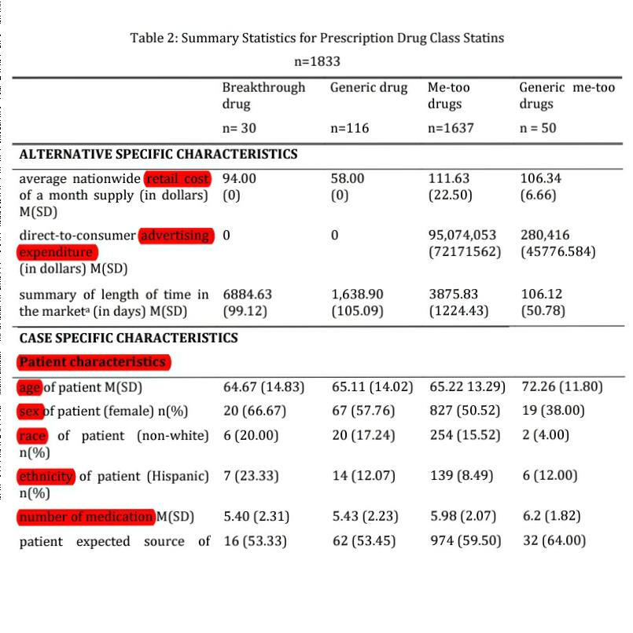

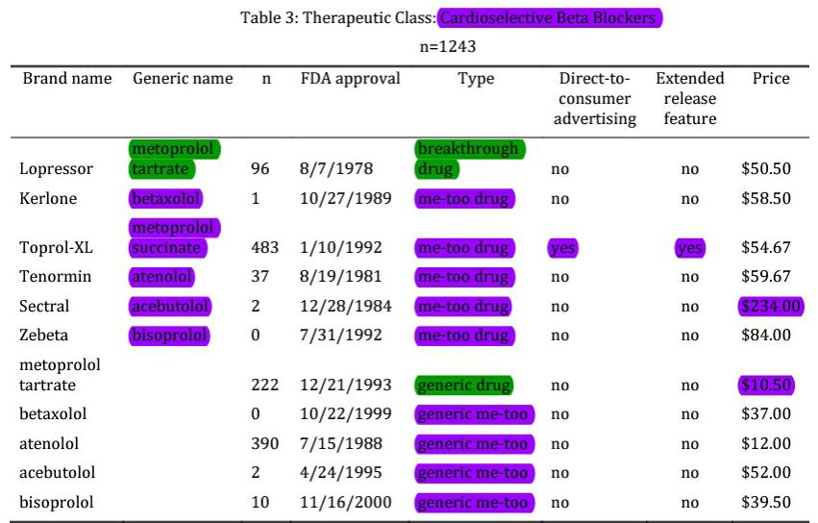**SAMPLE: CARDIOSELECTIVE BETA BLOCKERS** 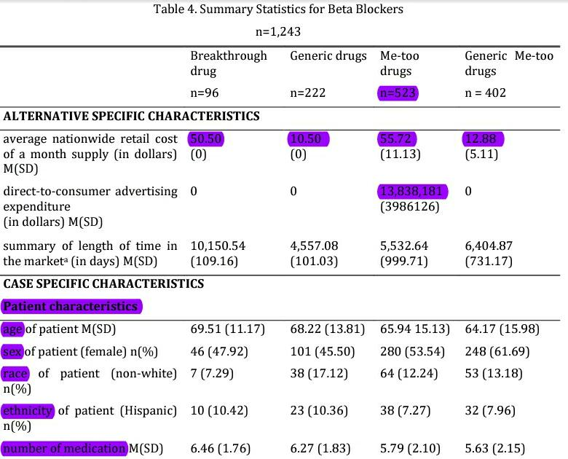



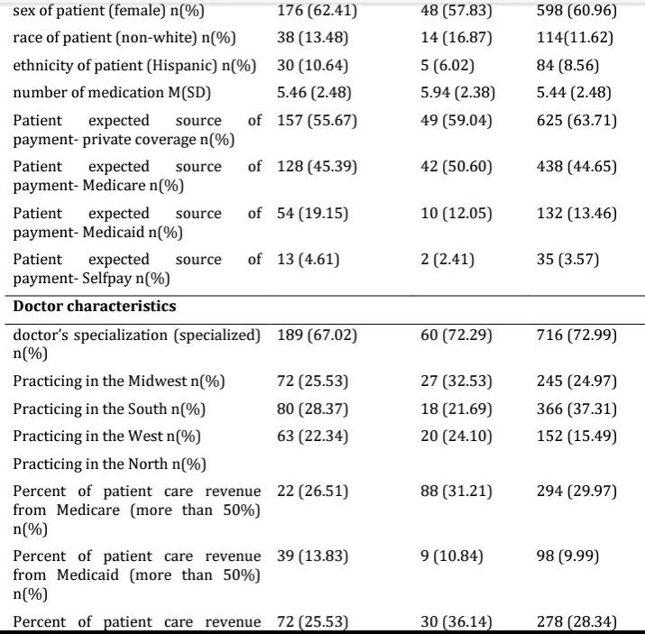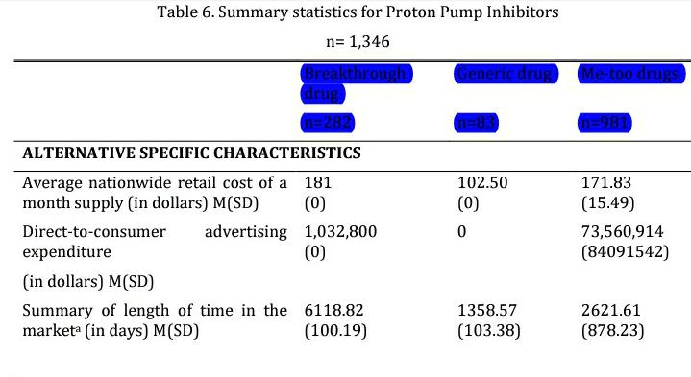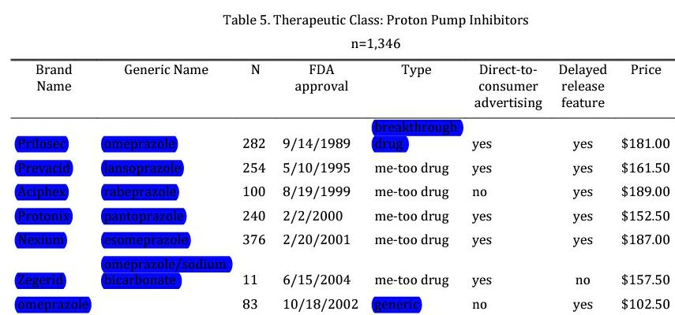**SAMPLE: PROTON PUMP INHIBITORS**

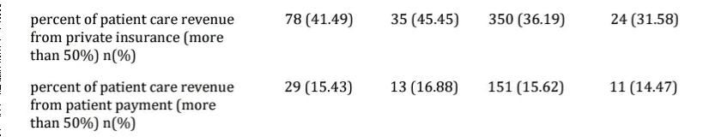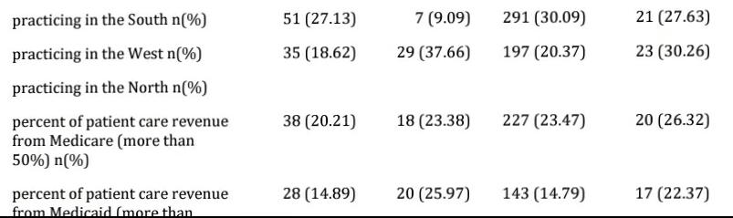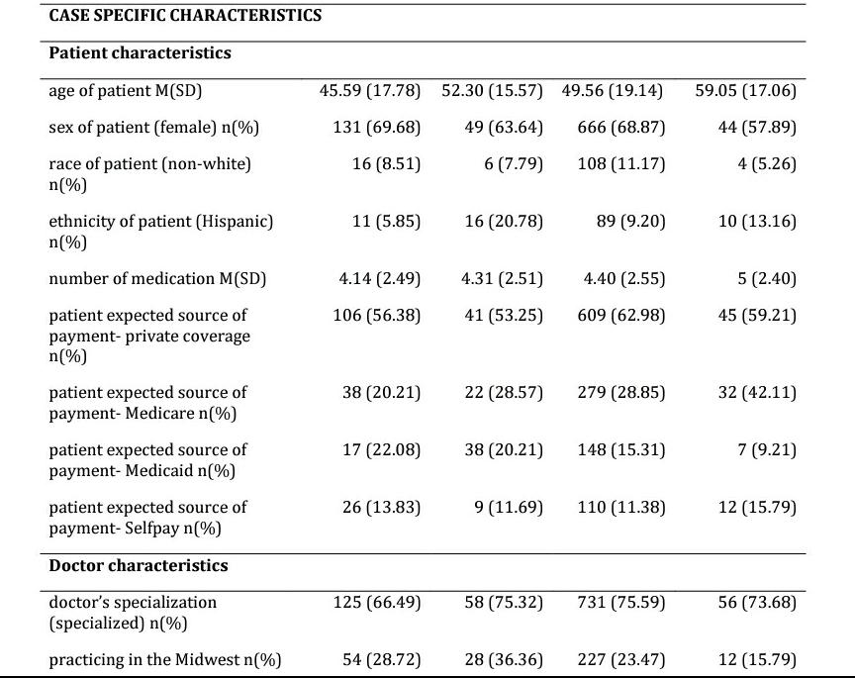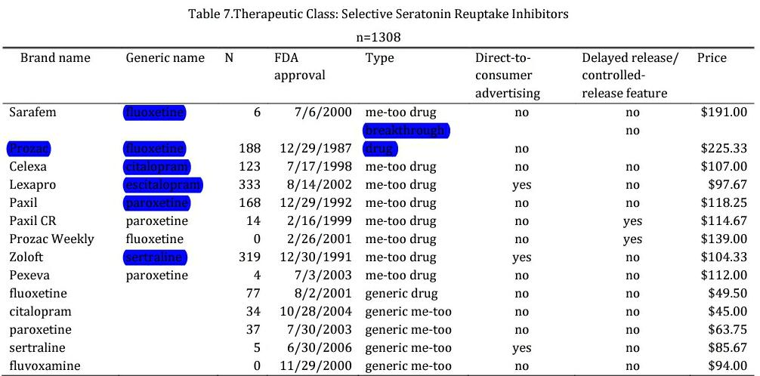**SAMPLE: SELECTIVE SEROTONIN REUPTAKE INHIBITORS (SSRI)**

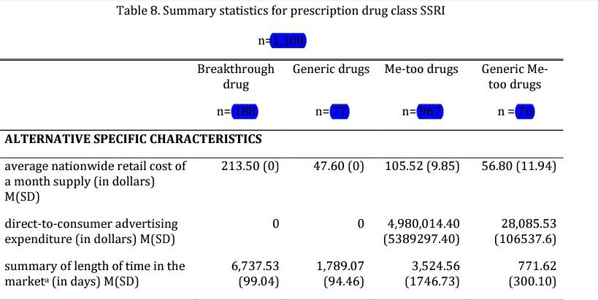

**RESULTS AND DISCUSSION**

Based on the results of the nested logit models with IV for the four classes of drugs, price influences physician prescribing behavior.

The relationship between **price and physician prescribing behavior** is not consistent across the four classes of drugs. In the classes of statins and cardioselective beta blockers, an increase in price decreases the likelihood that a drug will be prescribed. Both were statistically significant at p<.01. In the case of SSRIs and PPIs, an increase in price will increase the likelihood that the drug will be prescribed. Both were also statistically significant at p<.001.

The regression results for the four classes of drugs show different relationships between **the length of time in the market and the physician prescribing behavior**. The results of statin and SRRIs validate our hypothesis that an increase in the length of time in the market will increase the likelihood that a drug will be prescribed. In the case of beta blockers, an increase in the length of time in the market reduces the likelihood of a drug from being prescribed. For PPIs, the variable is not statistically significant. The difference in the results of the length of time variable maybe explained by the sensitivity of patients to the quality of drugs, which varies depending on the class of drugs. It should be recalled that the older drugs in the class are the breakthrough drugs and some me-too drugs. Generic drugs usually enter the market 15 to 20 years after the branded drugs were introduced in the market. The lingering perception that generic drugs are inferior than branded drugs may influence the preference for established branded drugs in the class of statin and SSRIs. The concerns with respect to the difference in the “bioavailability” of active ingredient between branded and generic drugs particularly for drugs with very narrow therapeutic band like SSRIs can also explain the preference for established drugs in the market. In the case of cardioselective beta blockers, the negative correlation between length of time and physician preference supports the view that generic drugs are as riskier as brand name drugs. Furthermore, since most of these cardioselective betablockers are maintenance medication. Patients are expected to regularly take them in the long term. This has implication on costs. The generic drugs have been in the market for a fairly shorter period of time than the branded drugs. Preference to prescribe generic drugs is consistent with the previous finding that physicians favor cheaper drugs among cardioselective beta blockers.

The statistically significant positive relationship between **direct-to-consumer advertising and physician prescribing behavior**  is consistent in the three classes of drugs – statin, cardioselective beta blockers and PPIs. This variable is not statistically significant in the class of SSRIs. An increase in direct-to-consumer advertising expenditure increases the likelihood that the prescription drug will be prescribed by a physician. The significance of direct-to-consumer advertising expenditure in the physician’s choice of prescription drug may suggest that patients play a role in the selection of their prescription drugs. Information gathered by patients from direct-to-consumer advertising empowered patients to play a role in the selection of their medication. The significant effect of direct-to-consumer advertising in the prescribing behavior of physicians may also be explained by the correlation between higher levels of advertising and concentration of physician prescribing (Stern & Trajtenberg, 1998).

This research found some **patient characteristics** to be statistically significant in influencing physician prescribing behavior. In the case of statins, an increase in age increases the likelihood that a physician will prescribe a generic drug than a me-too drug (p<.05). Older persons tend to be prescribed generic drug than me-too drug. The same observation applies to cardioselective beta blockers. An increase in age increases the likelihood that a person will be prescribed a generic drug than a me-too drug or generic me-too drugs. Both are significant at p<.05. This suggests that physicians are more likely to prescribe the generic drug to older patients. Age is not a statistically significant variable for SSRIs and PPIs.

Sex is also a statistically significant determinant of physician prescribing behavior in statins, cardioselective beta blockers and SSRIs

Race was also a significant determinant in the case of cardioselective beta blockers. Being non-white decreases the physician’s likelihood of prescribing breakthrough drug than the generic drug compared to being white (p≤.05). Race is not significant in the other classes of drugs. Ethnicity is statistically significant in the SSRIs.

The patient’s number of medication is a statistically significant determinant of physician prescribing behavior in statins and cardioselective beta blockers. In the statins class, an increase in the number of medication increases the probability of a physician prescribing me-too drugs relative to the probability of prescribing generic drug. In the case of cardioselective beta blockers, an increase in the number of medication decreases the probability of the physician prescribing me-too and generic me-too drugs relative to the probability of prescribing generic drug. Again, the nature of the relationship depends on the class of drugs.

For SSRIs and statins, the patient’s source of payment is also a statistically significant predictor of physician prescribing behavior. In the class of statins, Medicare as an expected source of payment increases the probability of a physician prescribing me-too drugs than generic drug compared to self-paying patients (p<.05). In the class of SSRIs, patients with private insurance are more likely than self-paying patients to be prescribed me-too drugs than generic drug (p<.05). In both statins and SSRIs, patients with Medicaid are more likely than self-paying patients to receive a generic drug prescription than generic me-too drugs prescription (p ≤ .05). This finding that some types of patients’ source of payment are statistically significant in influencing physician prescribing behavior suggests moral hazard. The observation that patients with Medicare or private insurance are more likely than self-paying patients to receive a prescription of me-too drugs than generic drug and patients with Medicaid are more likely than self-paying patients to receive a prescription for generic drug than me-too drug is consistent with the theory of moral hazard and previous findings that patients with more generous insurance coverage tent to receive more expensive drugs. Howard’s findings on moral hazard when he examined the antibacterial drug class using the 1994 NAMCS data showed that self-paying patients are significantly more likely than patients with Medicare or private insurance to be prescribed the generics (Howard, 1997).

There are some **physician characteristics** that are statistically significant in this study. These findings suggest that some physicians have the propensity to prescribe generic drugs while others tend to prescribe the breakthrough drug or me-too drugs, consistent with Hellerstein’s findings (Hellerstein, 1994).

In the case of statins, physicians with specialized practice are less likely than physicians with general practice to prescribe breakthrough drugs than generic drug (p<.05). This variable is not statistically significant in the other classes of drugs examined in this research.

In addition, there are regional differences in physician prescribing behavior. In the statins class, physicians who are practicing in the Midwest are less likely than physicians in the Northeast to prescribe breakthrough and me-too drugs than the generic drug (p<.05). Physicians in the West are more likely than physicians in the Northeast to prescribe generic drug than breakthrough, metoo and generic me-too drugs (p<.05). Physicians in the South are more likely than physicians in the Northeast to prescribe generic drug than me-too drugs and generic me-too drugs (p<.05). On the contrary, in the case of cardioselective beta blockers and PPIs, physicians who practice in the South are more likely than physicians in the Northeast to prescribe me-too than generic drugs (p<.05). In the case of SSRIs, physicians from the Midwest are more likely than the physicians from the Northeast to prescribe generic than generic me-too drugs (p<.01). Physicians from the South are more likely than patients in the northeast to prescribe branded drugs (breakthrough and me-too drugs) than generic drug (p<.05). Physicians from the West are more likely than physicians from the Northeast to prescribe generic drug than me-too drugs (p<.05). These may be explained by different state policies influencing physician prescribing behavior. However, because of limited Data, this study was not able to test that. In proton pump inhibitors, physicians with greater than 50% patient care revenue from private insurance are more likely to prescribe the generic drug than the breakthrough drug compared to physicians with less than 50% patient care revenue from private insurance (p<.05). Similarly, in the SSRI class, physicians with greater than 50% patient care revenue from private insurance are more likely to prescribe the generic drug than generic me-too drugs compared to physicians with less than 50% patient care revenue from private insurance (p<.05).

**THE EFFECT OF THE ENTRY OF ME-TOO DRUGS ON THE DEMAND FOR GENERIC DRUGS**

This study showed how changes in in price, length of time in the market and direct-to consumer advertising expenditure will affect the predicted market share of the different types of drugs in the market. **The effects of price and length of time in the market on predicted market shares are mixed. They depend on the drug class.**  However, **the effect of an increase in direct-to consumer advertising expenditure is consistent across classes.** It increases the market share of the advertised drug and decreases the market shares of the other drugs. This suggests that direct-toconsumer advertising can have combative effect in the pharmaceutical industry, shifting consumer preference to the advertised products. In the drug classes’ statins and beta blockers, an increase in direct-to-consumer advertising expenditure of me-too drugs negatively affects the predicted market shares of generic drugs (both the generic and generic me-too drugs combined) more than the breakthrough drug. In PPIs, increase in direct-to-consumer advertising of me-too drugs negatively affects the predicted market share of the breakthrough drug more than the generic drug. This section showed that the spending of me-too drugs on direct-to-consumer advertising greatly contributes in the increase in its market share. In most cases, the increase in market share of me too drugs because of direct-to-consumer advertising negatively affects the market share of generic drugs. The effects of the changes in direct-to-consumer advertising of me-too drugs on the market share of breakthrough drugs and generic drugs support previous findings that the entry of me-too drugs in the market reduces the incentives to conduct research of new drugs as it reduces the market exclusivity of breakthrough drugs. Me-too drugs also increase drug spending. An increase in the direct-to-consumer advertising expenditure of me-too drugs reduces the market share of generic drugs, which usually are the cheaper drugs in the market.

**CONCLUSION**

These findings suggest that physicians consider some patient characteristics in prescribing medication.

Significant physician characteristics include the region of practice, specialization and their primary source of revenue. The patient’s expected source of payment increases the likelihood of the patient from receiving one type of the drug over the other.

Sometimes, an increase in price increases the likelihood of a drug from being prescribed. In other times, it decreases. It suggests that physicians have certain level of awareness on price of drugs. An increase in drug’s length of time in the market is likely to increase the prescription of the drug but in the class of proton pump inhibitors, physicians are more likely to prescribe newer drugs.

The study found that direct-to-consumer advertising significantly affect physician prescribing behavior. The nature of the effect of direct-to consumer advertising on the prescribing behavior of physicians is consistent across the four classes of drugs. Direct-to-consumer advertising increases the likelihood that the drug will be prescribed.

This study explored how changes in in price, length of time in the market and direct-to-consumer advertising expenditure affect the predicted market share of the different types of drugs in the market. The effects of price and length of time in the market on predicted market shares are mixed. They depend on the drug class. However, the effect of an increase in direct-to-consumer advertising expenditure on predicted market shares of prescription drugs is consistent across classes. It increases the market share of the advertised drug and decreases the market shares of the other drugs.

This study also suggests that direct-to-consumer advertising of me-too drugs will increase its market share and reduce the market share of generic drugs. This implies an increase on prescription drug spending with little associated quality gain. With this, the current government policy regarding the approval of prescription drugs on the basis of its efficacy against a placebo should be amended. It is important that the efficacy of new drugs be tested against the existing drugs in the market to make sure that patients are getting the worth of every additional dollar spent on medications.

Pharmaceutical advertising is the primary instrument in informing patients about drugs.

**References**

Magno Gatmaytan “Influencing physician prescribing behavior: direct-to-consumer advertising and the demand for me-too drugs”, Northeastern University Boston, Massachusetts ,2013.